
PeiZen, Inc.
1227 Flynn Road
Camarillo, CA 93012
Phone: (805) 484-2454, FAX: (805) 383-5909
e-mail: hlee@flatmonitors.com
Website: www.flatmonitors.com

Q-1700-RK

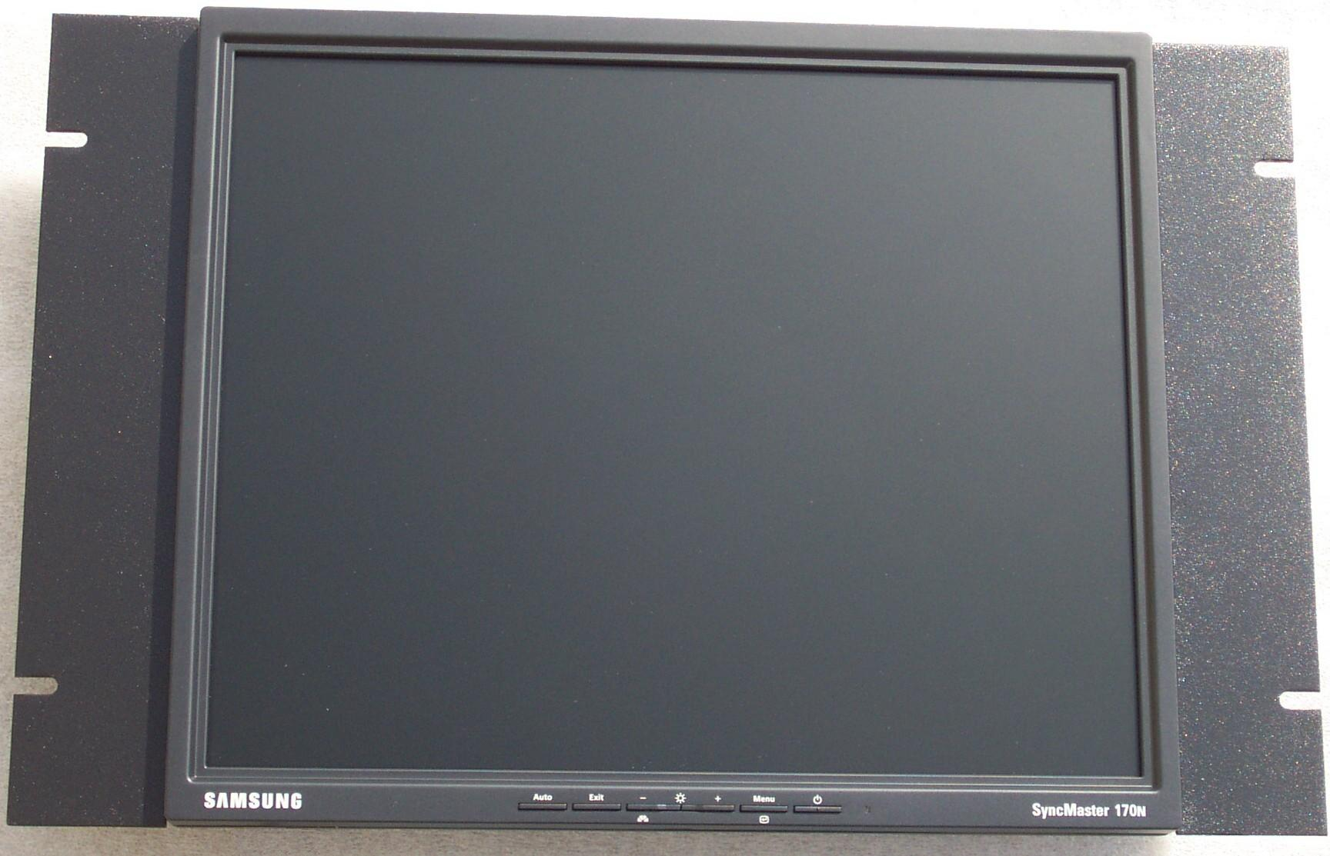

Front view of the Samsung 170N-Black assembled onto the Q-1700-RK

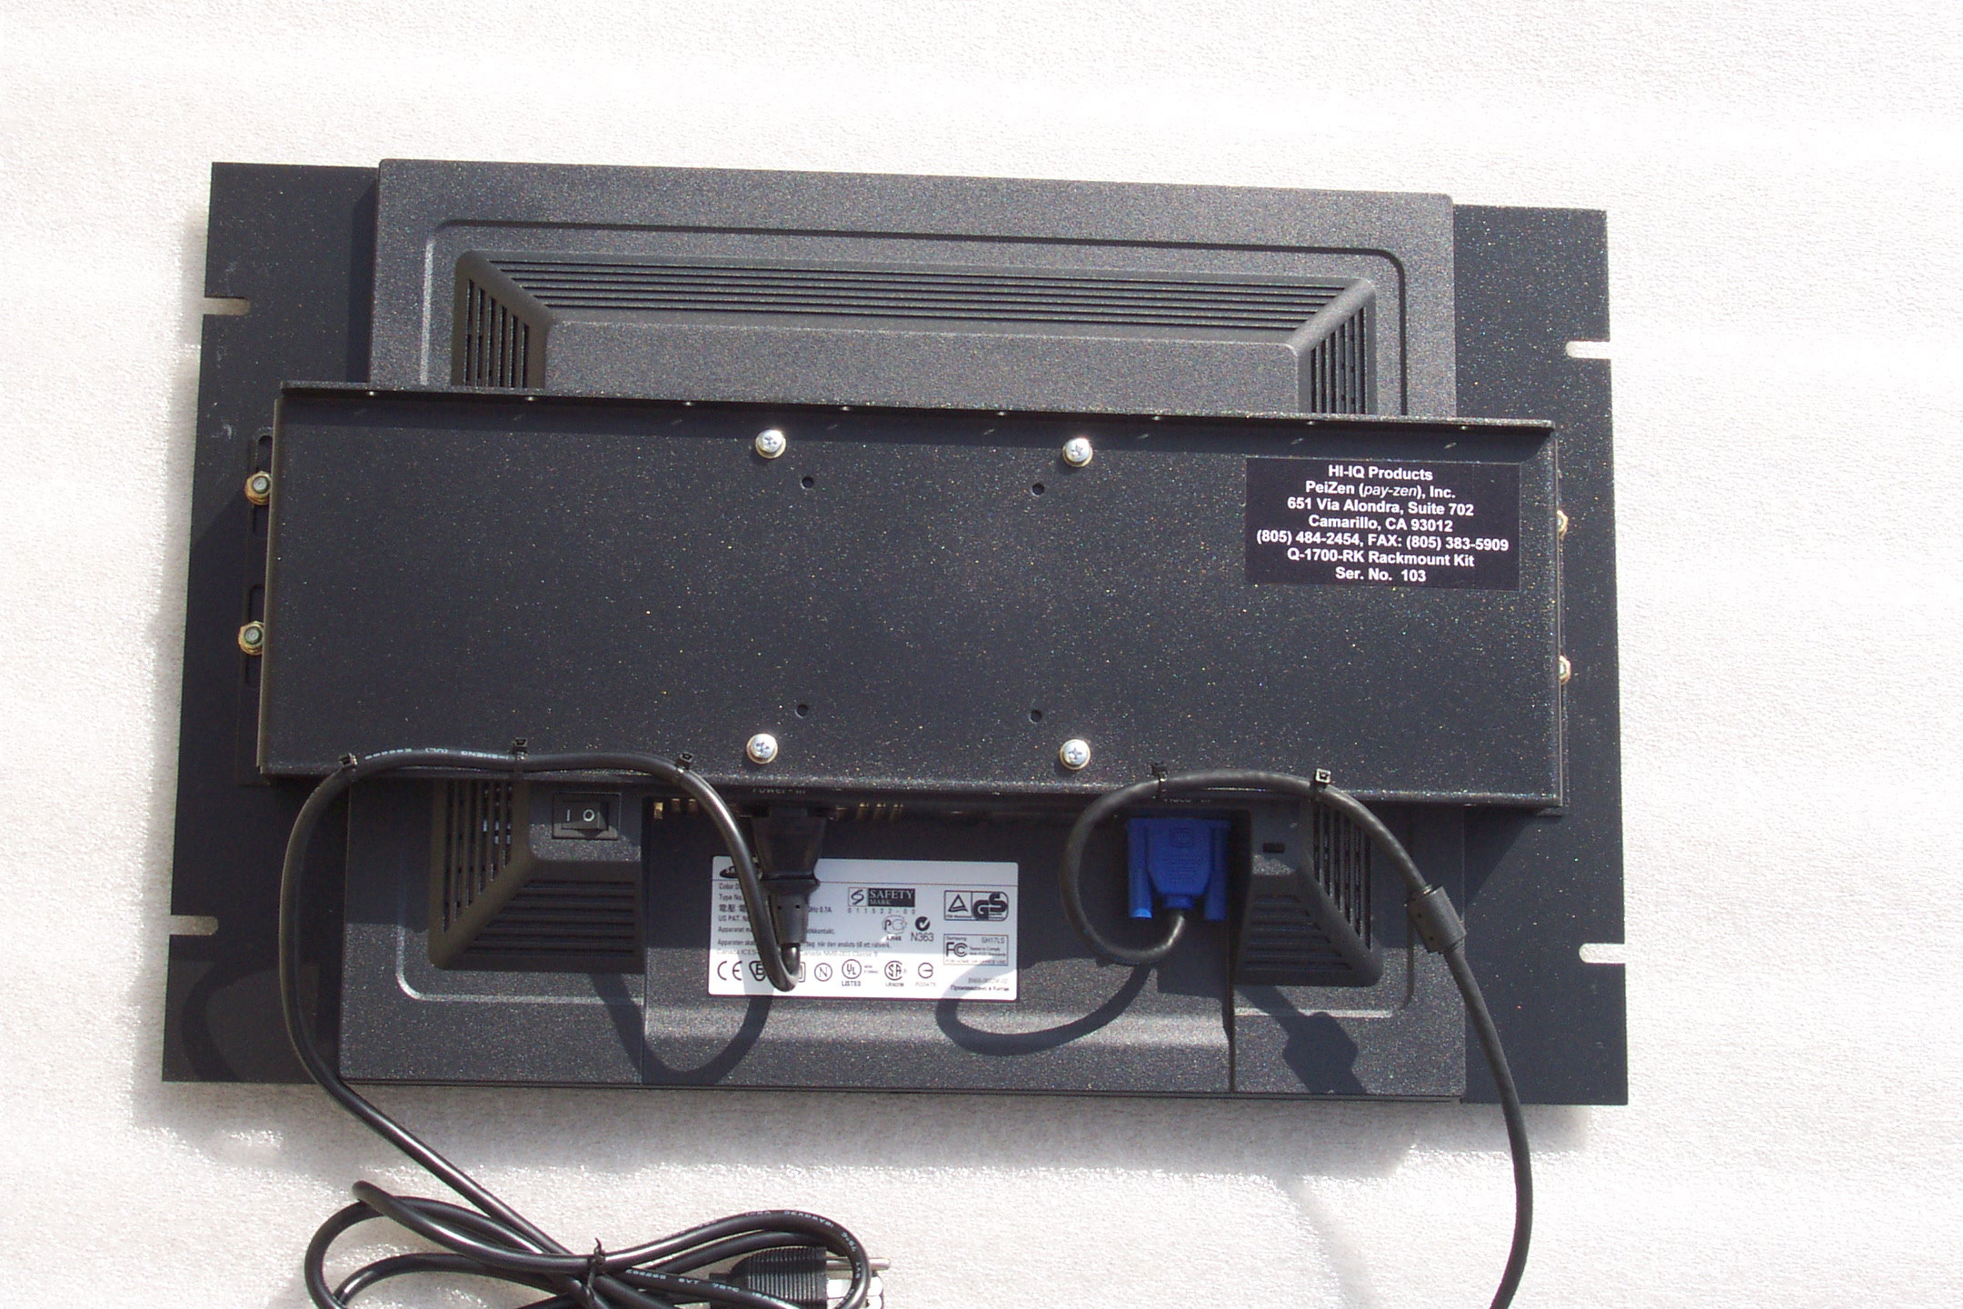 | This rackmount kit is 7U or 12.25” vertical high. The Q-1700-RK is very easy to assemble. It is designed specifically for the following 17” TFT LCD monitors:  Samsung 170N-Black, click on http://www.samsungusa.com/cgi-bin/nabc/product/b2c_product_detail.jsp?prod_id=170N-Black for its specifications, and  Viewsonic VP171b, click on http://www.viewsonic.com/products/lcd_vp171b.htm  for its specifications.
Rear view of the Samsung 170N-Black 17” TFT LCD monitor mounted onto the Q-1700-RK rackmount kit. | The total price for this rackmount monitor assembly may be less than $679.00 when assembled by the customer.

