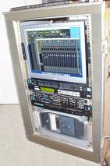 | 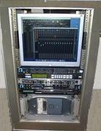
HP F1903 mounted with Q-1517-RK by Matthew Polashek
matt@tinysongs.com
www.tinysongs.com

